**FollowUp 0**

1. Run the 01_image_processing_PIL_tutorial.ipynb
2. Masks are geometric filters on an image. For instance, if we want to extract a region of an image, we may do it by multiplying the matrix of the original image by a matrix of equal size containing 1′s in the region we want to keep and 0′s otherwise.

In this exercise we extract a circular region of the image ***[lena_gray_512.tif](http://www.unioviedo.es/compnum/labs/new/files/lena_gray_512.tif)*** of radious 150. Follow the next instructions and report every step:

* Read the image and convert it to double.
* Create a matrix of the same dimensions filled with zeros.
* Modify the above matrix to contain 1′s in a circle of radious 150, i.e. if (j−cx)2+(i−cy)2<150exp2, where (cx,cy) is the center of the image.
* Multiply the image by the mask (they are matrices!)
* Show the results.

When multiplying by zero, you set to black the pixels out of the circle. Modify the program to make visible those pixels with half the intensity.

**Hint**

**a.shape[0]** is the number of rows of **a** and **a.shape[1]** the number of columns.

1. Briefly compare PIL and CV2 libraries, similarities, strengths and weakness.

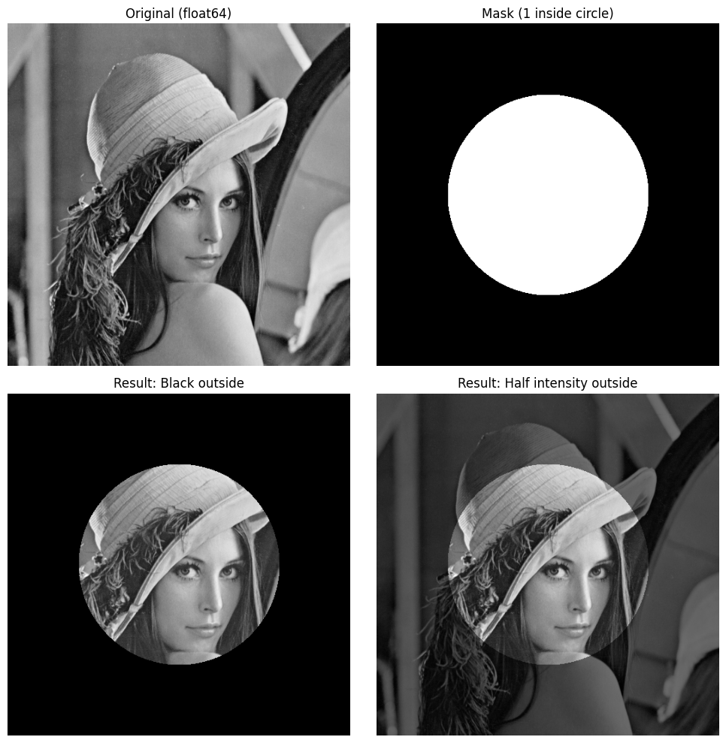

## Brief comparison: PIL vs OpenCV (cv2)

- **Similarities**

- Both can read, write, and display images.

- Both support color conversions, resizing, cropping, drawing, and basic filtering.

- **Strengths (PIL / Pillow)**

- Pythonic, lightweight, easy for simple image I/O and manipulation.

- Integrates nicely with NumPy; arrays are easy to convert with `np.asarray(Image)` and `Image.fromarray`.

- Great for pipelines that generate or annotate images for reports/plots with Matplotlib.

- **Weaknesses (PIL / Pillow)**

- Limited advanced computer vision algorithms (e.g., feature detection, optical flow, DNN inference).

- Performance not as optimized for large-scale CV tasks.

- **Strengths (OpenCV / cv2)**

- Very fast C++ backend; broad set of algorithms for computer vision, image processing, and video.

- Extensive functionality: filtering, morphology, geometric transforms, feature matching, camera calibration, DNN module, etc.

- Good for production-grade CV pipelines and real-time processing.

- **Weaknesses (OpenCV / cv2)**

- API can be less Pythonic; color channel order is BGR by default.

- Heavier dependency; installation can be larger and sometimes trickier.

- **Summary**

- Use PIL for simple, lightweight image I/O and basic transformations in Python notebooks/scripts.

- Use OpenCV when you need performance and a comprehensive set of CV algorithms or real-time video processing.